## **COMPUTE MONITOR DASHBOARD**

# **Snowsight Dashboard Setup**

## 1. Create a Dashboard

Login to the account and navigate to the **tab dashboard** in the left side options ,then click on the **+dashboard** option highlighted in blue to create a new dashboard.

## 2. Name the dashboard

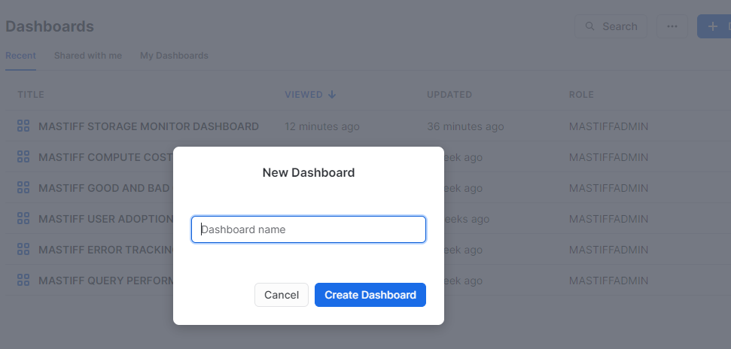

Next step is to give an appropriate name to the dashboard and click **Create Dashboard**.

## 3. Setup the Role and Warehouse

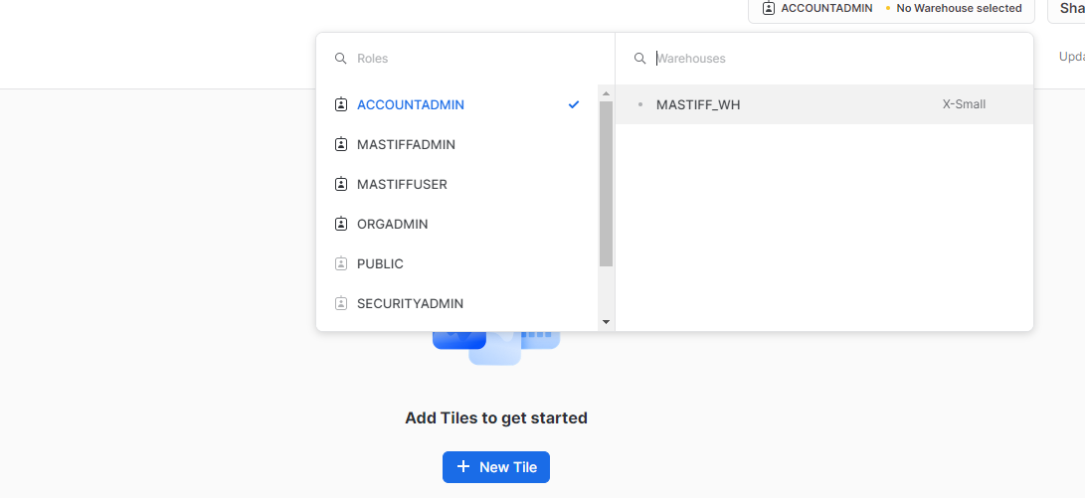

## 4. Creating KPIs and Charts

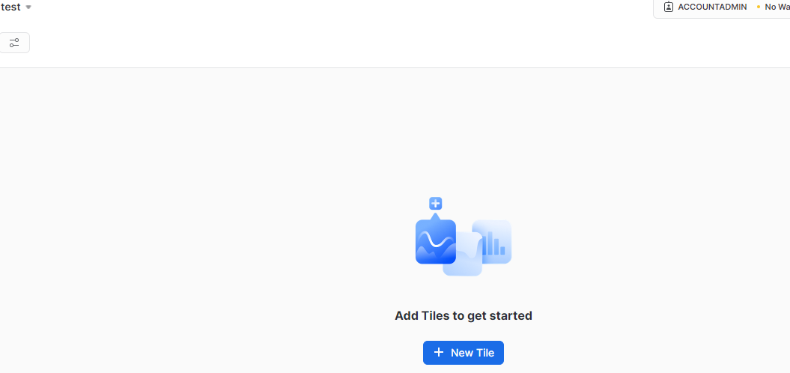

To create KPIs and charts, start by adding a new tile by clicking **+New Tile .**

## 5. Adding names to the KPIs and Executing the queries.

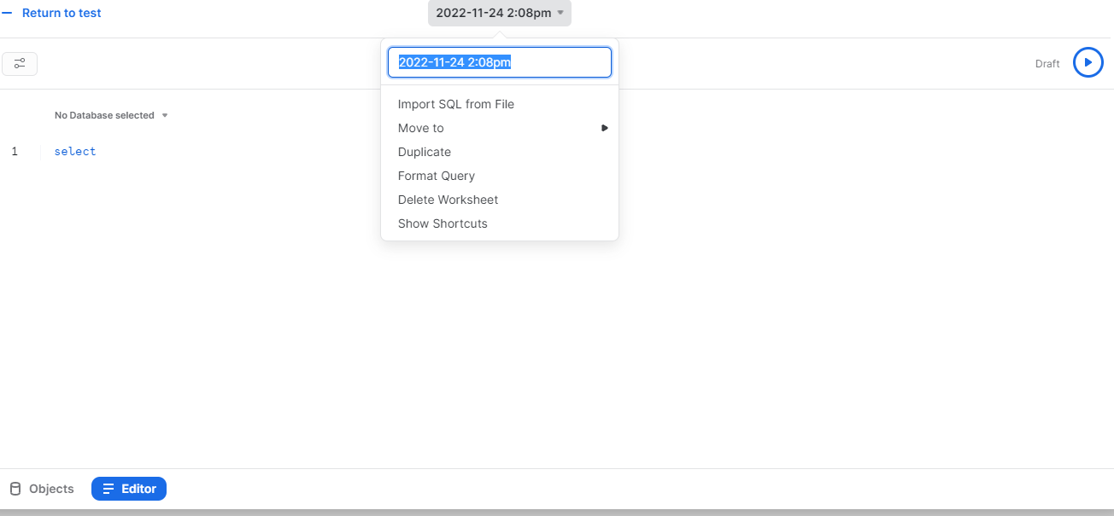

We can name the KPI by clicking the date followed by the time and changing it to the required name. To execute a query, type in the editor and click the run button to get the desired results.

**Note :** Before you create all the dashboards in Snowsight, Use the role **MONITOR_ADMIN** and warehouse **MONITOR_WH** to create dashboards in SNOWSIGHT for Watchkeeper.

## **MONITOR COMPUTE CREDIT MONITORING DASHBOARD**

**Note -** Here we have also implemented color coding for filters to show an indication that which filter is for which tiles.

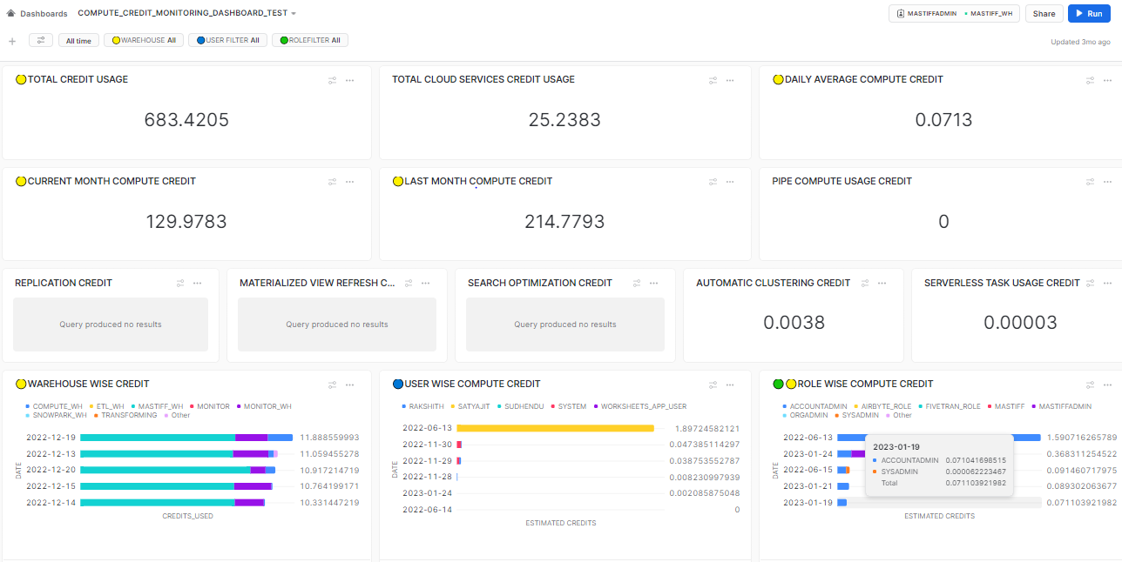

## **Filters :**

**Customize the filter query's refresh frequency to align with your requirements. If you regularly analyze dashboards, consider refreshing it daily for up-to-date data. However, if dashboard analysis is infrequent, opt for "never refresh" to reduce unnecessary costs. Keep in mind that choosing "never refresh" means running filter query manually when utilizing the dashboard, which can be done from the filter section.**

### **Warehouse Filter :-**

**Display Name** :- WAREHOUSEFILTER

**SQL Keyword** :- WAREHOUSEFILTER

**Role** :- MONITOR_ADMIN

**Warehouse** :- MONITOR_WH

**Options Via** :- Query

**Write Query** :- SELECT DISTINCT(WAREHOUSE_NAME) FROM MONITOR_DB.COMPUTE_CREDIT_MONITOR_SCHEMA.TABLE_WAREHOUSE_MONITOR;

Go for the below selections :-

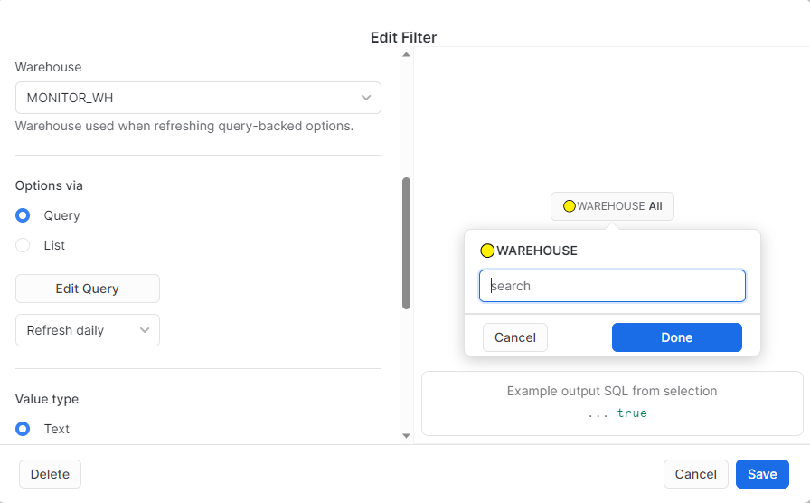

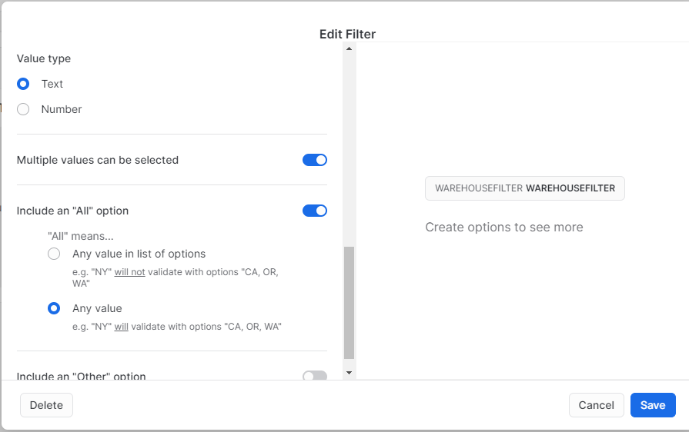

### **Role Filter :-**

**Display Name** :- ROLEFILTER

**SQL Keyword** :- ROLEFILTER

**Role** :- MONITOR_ADMIN

**Warehouse** :- MONITOR_WH

**Options Via** :- Query

**Write Query** :- SELECT DISTINCT(ROLE_NAME) FROM MONITOR_DB.COMPUTE_CREDIT_MONITOR_SCHEMA.TABLE_ROLE_MONITOR;

Go for the below selections :-

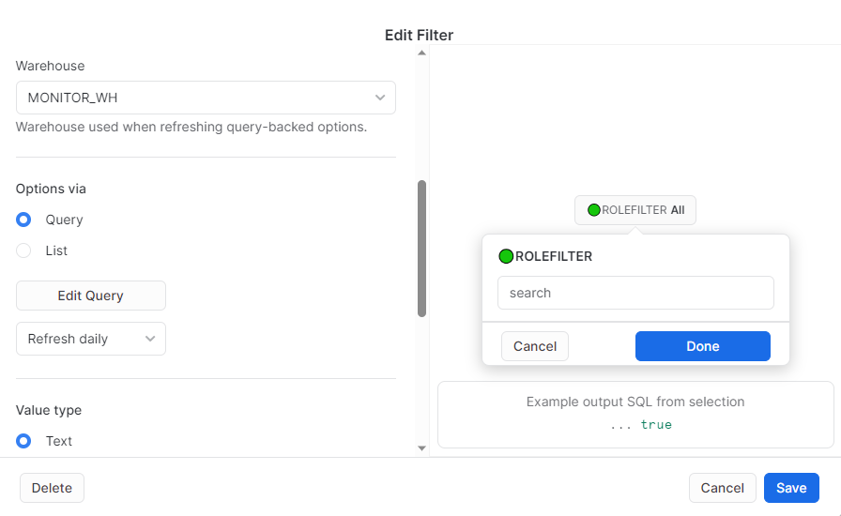



### **User Filter :-**

**Display Name** :- USERFILTER

**SQL Keyword** :- USERFILTER

**Role** :- MONITOR_ADMIN

**Warehouse** :- MONITOR_WH

**Options Via** :- Query

**Write Query** :- SELECT DISTINCT(USER_NAME) FROM MONITOR_DB.COMPUTE_CREDIT_MONITOR_SCHEMA.TABLE_USER_MONITOR;

Go for the below selections :

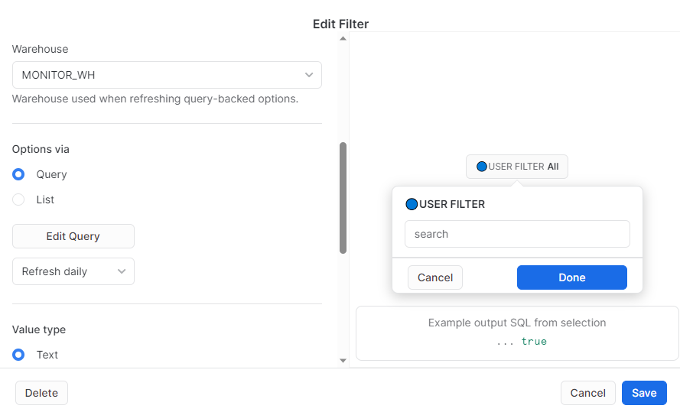



### **Month Filter :-**

**Display Name** :- MONTH

**SQL Keyword** :- MONTH

**Role** :- MONITOR_ADMIN

**Warehouse** :- MONITOR_WH

**Options Via** :- Query

**Write Query** :-

SELECT DISTINCT(MONTHNAME(START_DATE)) as month_name FROM MONITOR_DB.COMPUTE_CREDIT_MONITOR_SCHEMA.TABLE_WAREHOUSE_MONITOR;

Go for the below selections :

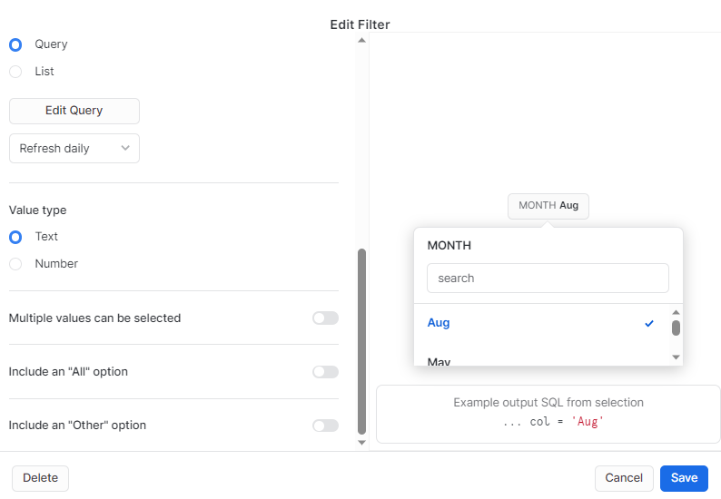

### **Year Filter :-**

**Display Name** :- YEAR

**SQL Keyword** :- YEAR

**Role** :- MONITOR_ADMIN

**Warehouse** :- MONITOR_WH

**Options Via** :- Query

**Write Query** :-

SELECT DISTINCT(YEAR(START_DATE)) FROM MONITOR_DB.COMPUTE_CREDIT_MONITOR_SCHEMA.TABLE_WAREHOUSE_MONITOR;

Go for the below selections :

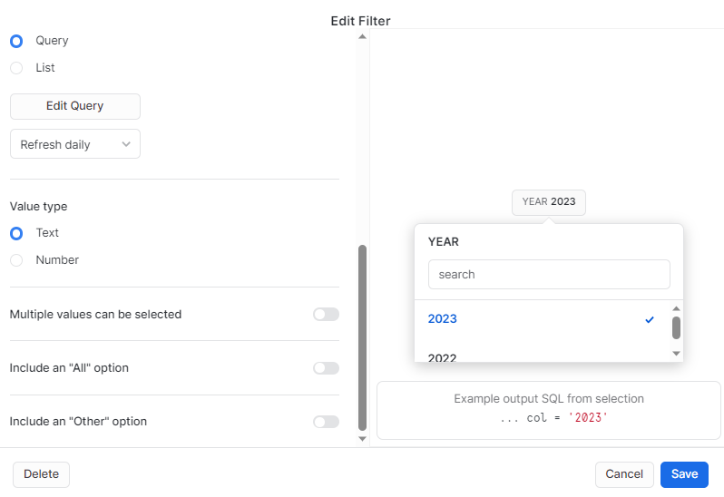

### Below table shows the list of filters and the KPIs it is associated with for the Compute Credit Monitoring Dashboard

| **FILTERS** | **KPIs** |
| --- | --- |
| Warehouse | * Total Credit Usage * Average Compute Credit * Current Month Compute Credit * Last Month Compute Credit * Compute Credits by Month * Warehouse Wise Credit * Role Wise Compute Credit * User Wise Compute Credit |
| Role | * Role Wise Compute Credit |
| User | * User Wise Compute Credit |
| Year | * Current Month Compute Credit * Last Month Compute Credit |
| Month | * Current Month Compute Credit * Last Month Compute Credit |

### 

### **1.1 TOTAL WAREHOUSE CREDIT USAGE (Compute + Cloud)**

select round(SUM(daily_credits_used),4)from MONITOR_DB.COMPUTE_CREDIT_MONITOR_SCHEMA.TABLE_WAREHOUSE_MONITOR where date=:daterange and warehouse_name= :WAREHOUSEFILTER;

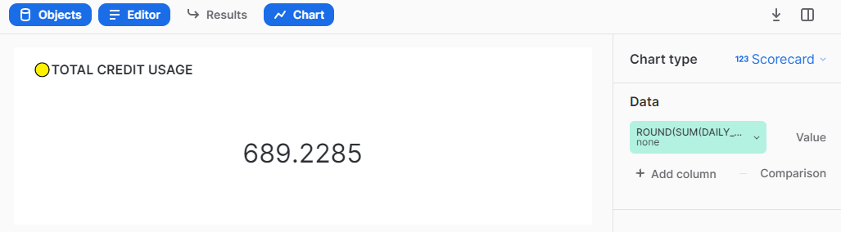

### **1.2 TOTAL CLOUD SERVICES CREDIT USAGE**

select round(sum(DAILY_CREDITS_USED_CLOUD),4) from MONITOR_DB.COMPUTE_CREDIT_MONITOR_SCHEMA.TABLE_WAREHOUSE_MONITOR

WHERE date=:daterange ;

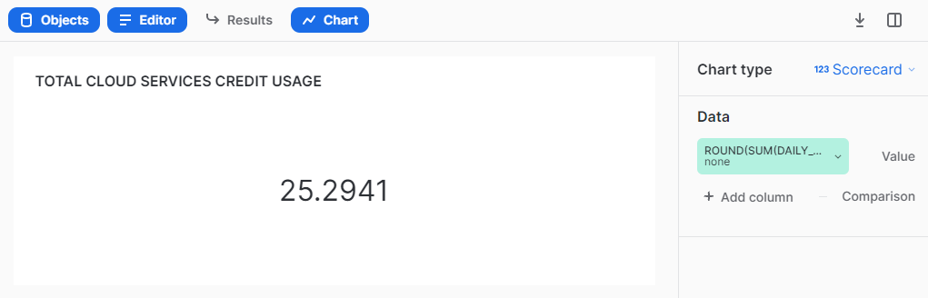

### 

### 

### **1.3 DAILY AVERAGE COMPUTE CREDIT BY WAREHOUSE**

select round(avg(daily_credits_used_all),2) from (select date(START_DATE),

sum(DAILY_CREDITS_USED) as daily_credits_used_all from MONITOR_DB.COMPUTE_CREDIT_MONITOR_SCHEMA.TABLE_WAREHOUSE_MONITOR where date=:daterange and warehouse_name=:WAREHOUSEFILTER group by date(START_DATE))as daily_credits_used_all_wh;

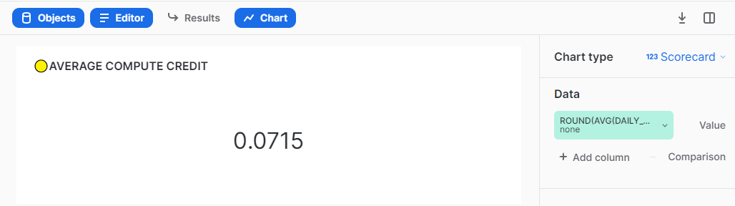

### 

### **1.4 CURRENT MONTH COMPUTE CREDIT BY WAREHOUSE**

**Ensure that you select the option for current month and year filters in order to view the desired KPI result.**

SELECT

CASE

WHEN (NOT EXISTS (select round(DAILY_CREDITS_USED,4) from MONITOR_DB.COMPUTE_CREDIT_MONITOR_SCHEMA.TABLE_WAREHOUSE_MONITOR

where YEAR(START_DATE) = YEAR(CURRENT_DATE()) AND MONTH(START_DATE) = MONTH(CURRENT_DATE()) and warehouse_name=:WAREHOUSEFILTER )) THEN 0

WHEN 1=1 THEN (select round(SUM(DAILY_CREDITS_USED),4) from MONITOR_DB.COMPUTE_CREDIT_MONITOR_SCHEMA.TABLE_WAREHOUSE_MONITOR

where YEAR(START_DATE) = :YEAR AND monthname(START_DATE) =:MONTH and warehouse_name=:WAREHOUSEFILTER )

END AS CURRENT_MONTH_COMPUTE_CREDIT;

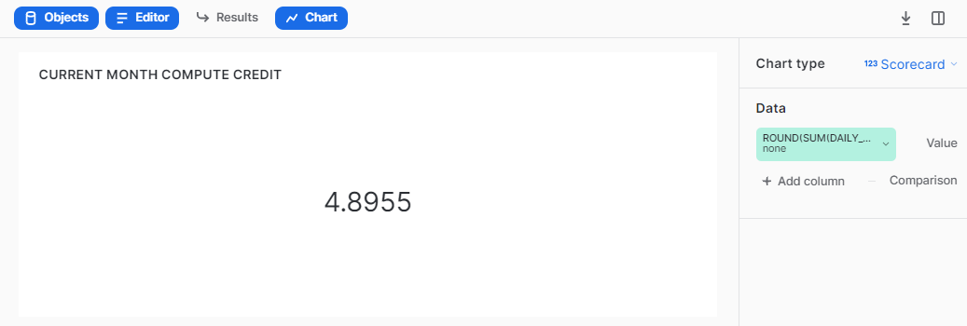

### 

### **1.5 LAST MONTH COMPUTE CREDIT BY WAREHOUSE**

**Ensure that you select the option for current month and year filters in order to view the desired KPI result.**

SELECT

CASE

WHEN ( 'Jan'= :MONTH ) THEN (SELECT Round(sum(DAILY_CREDITS_USED),2) FROM MONITOR_DB.COMPUTE_CREDIT_MONITOR_SCHEMA.TABLE_WAREHOUSE_MONITOR WHERE YEAR(START_DATE) = :YEAR -1 AND MONTHNAME(START_DATE) ='Dec' and warehouse_name=:WAREHOUSEFILTER)

WHEN 1=1 THEN (SELECT Round(SUM(DAILY_CREDITS_USED),2) FROM MONITOR_DB.COMPUTE_CREDIT_MONITOR_SCHEMA.TABLE_WAREHOUSE_MONITOR WHERE YEAR(START_DATE) =:YEAR AND MONTHNAME(add_months(START_DATE, +1)) =:MONTH and warehouse_name=:WAREHOUSEFILTER )

END AS LAST_MONTH_CREDIT;

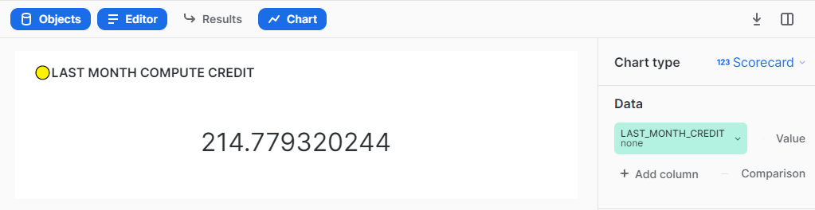

### **1.6 PIPE COMPUTE USAGE CREDIT**

SELECT

CASE

WHEN (NOT EXISTS (select round((daily_credits_used),4) from MONITOR_DB.COMPUTE_CREDIT_MONITOR_SCHEMA.TABLE_PIPE_MONITOR where date=:daterange)) THEN 0

WHEN 1=1 THEN (select round(sum(daily_credits_used),4) from MONITOR_DB.COMPUTE_CREDIT_MONITOR_SCHEMA.TABLE_PIPE_MONITOR where date=:daterange)

END AS PIPE_COMPUTE_USAGE_CREDIT;

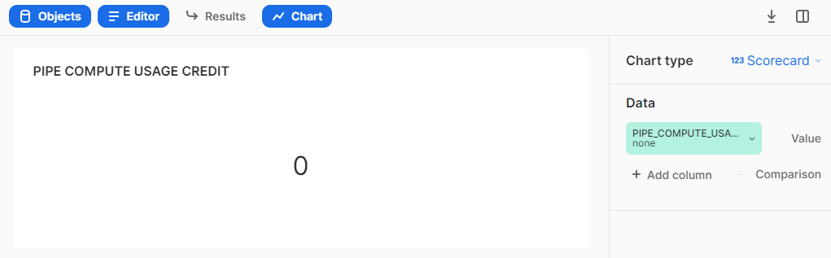

### 

### **1.7 REPLICATION CREDIT**

SELECT

CASE

WHEN (NOT EXISTS (SELECT round(daily_credits_used,4) FROM MONITOR_DB.COMPUTE_CREDIT_MONITOR_SCHEMA.TABLE_REPLICATION_MONITOR where date=:daterange)) THEN 0

WHEN 1=1 THEN (SELECT round(sum(daily_credits_used),4) FROM MONITOR_DB.COMPUTE_CREDIT_MONITOR_SCHEMA.TABLE_REPLICATION_MONITOR where date=:daterange)

END AS REPLICATION_CREDIT;

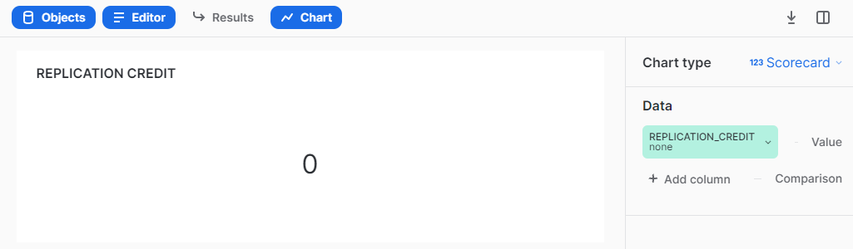

### **1.8 MATERIALIZED VIEW REFRESH CREDIT**

SELECT

CASE

WHEN (NOT EXISTS (SELECT round(daily_credits_used,4) FROM MONITOR_DB.COMPUTE_CREDIT_MONITOR_SCHEMA.TABLE_MATERIALIZEDVIEWREFRESH_MONITOR

where date=:daterange)) THEN 0

WHEN 1=1 THEN (SELECT round(sum(daily_credits_used),4) FROM MONITOR_DB.COMPUTE_CREDIT_MONITOR_SCHEMA.TABLE_MATERIALIZEDVIEWREFRESH_MONITOR

where date=:daterange)

END AS MATERIALIZED_VIEW_REFRESH_CREDIT;

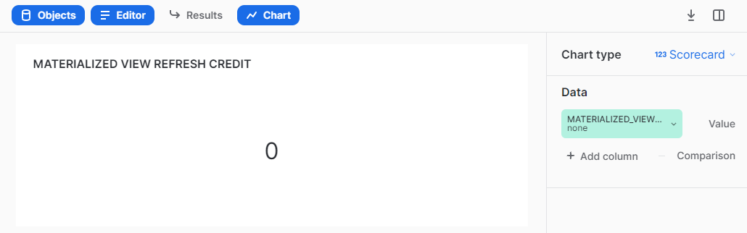

### 

### **1.9 SEARCH OPTIMIZATION CREDIT**

SELECT

CASE

WHEN (NOT EXISTS (SELECT round(daily_credits_used,4) FROM MONITOR_DB.COMPUTE_CREDIT_MONITOR_SCHEMA.TABLE_SEARCHOPTIMIZATION_MONITOR where date=:daterange)) THEN 0

WHEN 1=1 THEN (SELECT round(sum(daily_credits_used),4) FROM MONITOR_DB.COMPUTE_CREDIT_MONITOR_SCHEMA.TABLE_SEARCHOPTIMIZATION_MONITOR where date=:daterange)

END AS SEARCH_OPTIMIZATION_CREDIT;

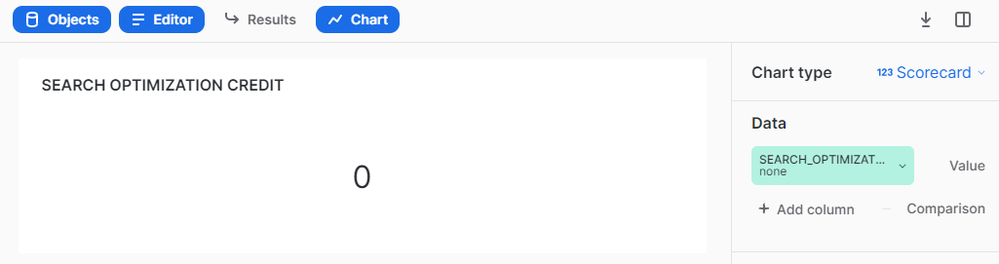

### 

### **1.10 AUTOMATIC CLUSTERING CREDIT**

SELECT

CASE

WHEN (NOT EXISTS (SELECT round(daily_credits_used,4) FROM MONITOR_DB.COMPUTE_CREDIT_MONITOR_SCHEMA.TABLE_AUTOMATICCLUSTERING_MONITOR where date=:daterange)) THEN 0

WHEN 1=1 THEN (SELECT round(sum(daily_credits_used),4) FROM MONITOR_DB.COMPUTE_CREDIT_MONITOR_SCHEMA.TABLE_AUTOMATICCLUSTERING_MONITOR where date=:daterange)

END AS AUTOMATIC_CLUSTERING_CREDIT;

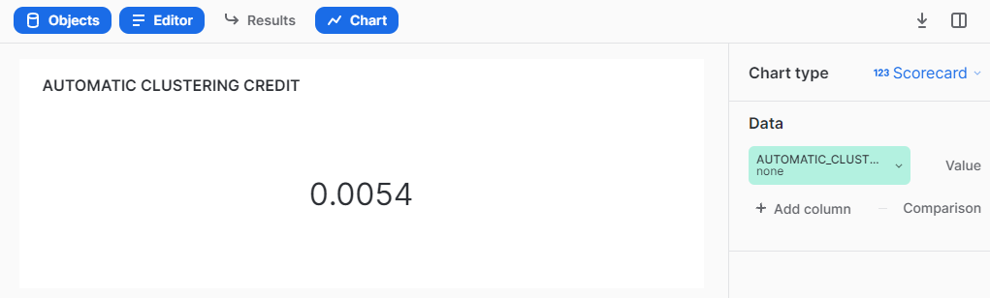

### 

### **1.11 SERVERLESS TASK USAGE CREDIT**

SELECT

CASE

WHEN (NOT EXISTS (SELECT round(daily_credits_used,5) FROM MONITOR_DB.COMPUTE_CREDIT_MONITOR_SCHEMA.TABLE_SERVERLESSTASK_MONITOR where date=:daterange)) THEN 0

WHEN 1=1 THEN (SELECT round(sum(daily_credits_used),5) FROM MONITOR_DB.COMPUTE_CREDIT_MONITOR_SCHEMA.TABLE_SERVERLESSTASK_MONITOR where date=:daterange)

END AS SERVERLESS_TASK_USAGE_CREDIT;

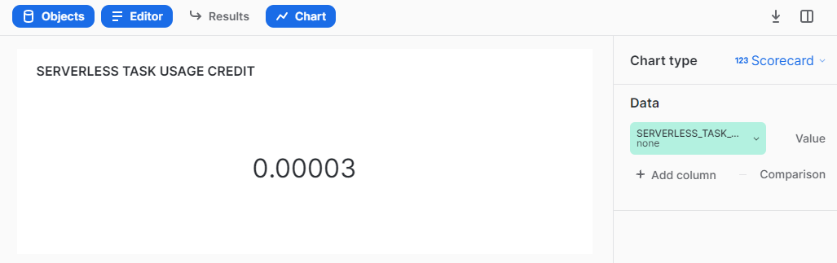

### 

### **1.12 WAREHOUSE WISE CREDIT (Compute + Cloud)**

SELECT * FROM MONITOR_DB.COMPUTE_CREDIT_MONITOR_SCHEMA.TABLE_WAREHOUSE_MONITOR

WHERE warehouse_name != 'CLOUD_SERVICES_ONLY' and START_DATE= :daterange AND WAREHOUSE_NAME= :WAREHOUSEFILTER;

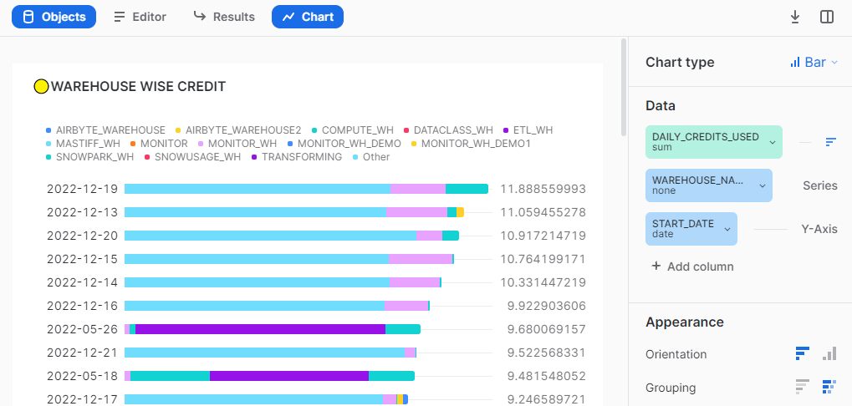

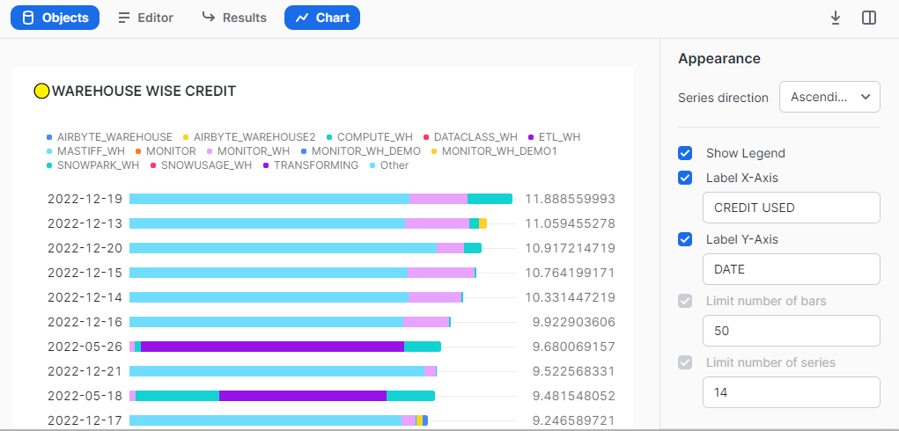

### 

### **1.13 USER WISE COMPUTE CREDIT**

SELECT * FROM MONITOR_DB.COMPUTE_CREDIT_MONITOR_SCHEMA.TABLE_USER_MONITOR WHERE DATE= :daterange AND USER_NAME= :USERFILTER;

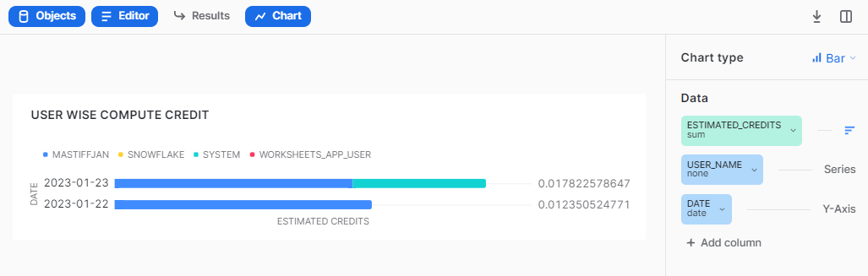

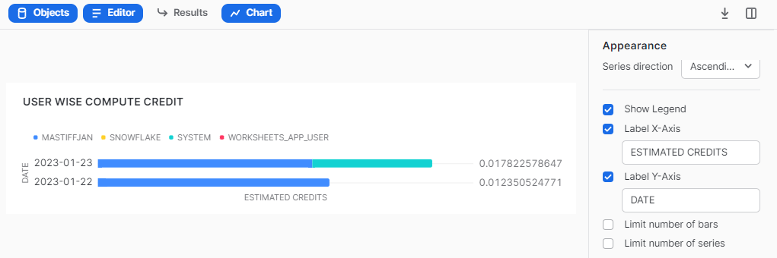

### **1.14 ROLE WISE COMPUTE CREDIT**

SELECT * FROM MONITOR_DB.COMPUTE_CREDIT_MONITOR_SCHEMA.TABLE_ROLE_MONITOR WHERE ROLE_NAME= :ROLEFILTER AND WAREHOUSE_NAME= :WAREHOUSEFILTER and date=:daterange;

## 

## 

### **1.15 CREDITS BY MONTH (Compute + Cloud)**

select start_date, round(SUM(DAILY_CREDITS_USED),4) as COMPUTE_CREDIT from MONITOR_DB.COMPUTE_CREDIT_MONITOR_SCHEMA.TABLE_WAREHOUSE_MONITOR

where start_date=:daterange and warehouse_name=:WAREHOUSEFILTER

group by 1;

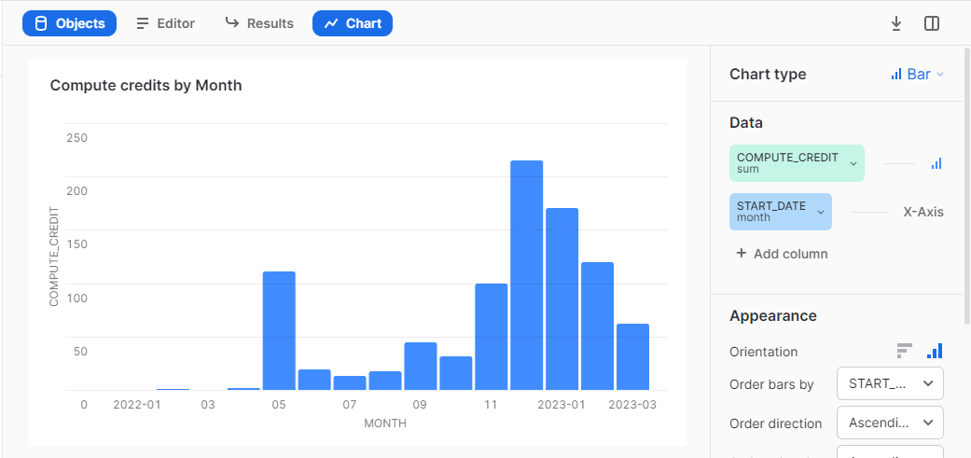

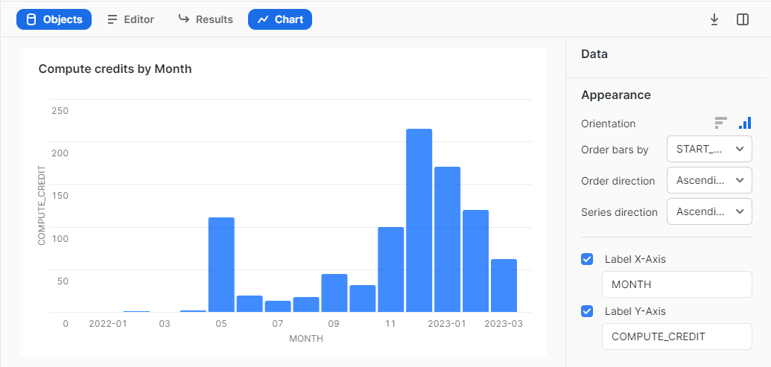

## **Best Practices -**

* If you have records more than 10000 then select only top 9999 ( refer. link:- <https://docs.snowflake.com/en/sql-reference/constructs/top_n.html>) to create a chart as Snowsight only supports data to be visualized till 9999 rows.
* It's preferable to do aggregation in the query itself rather than to do it in Snowsight UI.
* Adjust the round off value as per your requirement ( e.g - round((<column_name>), n) where n = natural number ).
* On hovering over any filter, visuals getting filtered would be highlighted.
* To make filter interaction more user friendly, you can even use color coding.
* Customize the refreshment time of the filter query according to your specific needs.